Retail Sales Trends and Product Performance Insights for Revenue Analysis
1. Abstract
Retail sales activity reflects how customer choices, product characteristics, and purchase conditions together influence overall revenue in an online shopping environment. Understanding these patterns helps explain why certain products perform better, why some purchases happen more frequently, and how offers or customer preferences affect buying decisions. This project examines retail sales trends by considering factors such as item category, purchase amount, customer location, product size, discount usage, promo code application, and subscription status to observe their impact on product performance. The analysis helps identify which product groups contribute more strongly to revenue and under what conditions sales increase or decline. It also provides insight into how promotional offers influence customer purchasing behaviour and how buying patterns differ across locations and customer segments. By studying these relationships, the project presents a clearer understanding of revenue movement and highlights the major factors that shape product performance in retail sales
2. INTRODUCTION
Background of the Domain
The retail industry has undergone a significant transformation over the past decade, driven largely by the rapid growth of e-commerce platforms and digital technologies. Traditional brick-and-mortar stores have increasingly integrated with online systems, creating a hybrid retail ecosystem where customers can browse, compare, and purchase products from anywhere at any time. This evolution has resulted in an enormous volume of transactional data being generated continuously, capturing every interaction between customers and products.
In an online retail environment, each purchase is influenced by multiple factors such as product type, pricing, discounts, promotional campaigns, customer preferences, geographic location, and purchasing power. Retail businesses no longer rely solely on intuition or historical sales summaries; instead, they depend on detailed data analysis to understand trends and make informed decisions. The availability of structured datasets containing attributes like item purchased, category, amount, location, size, discount usage, promo codes, and subscription status provides an opportunity to deeply analyze consumer behavior and revenue generation patterns.
Retail sales analysis, therefore, becomes a crucial domain within business analytics, focusing on extracting meaningful insights from sales data to improve decision-making. It involves identifying patterns in customer purchases, understanding which products perform well, analyzing the effectiveness of marketing strategies, and determining how various factors contribute to overall revenue. This project is situated within this domain, aiming to explore how multiple variables interact to influence retail sales performance and revenue outcomes.
Importance of the Problem
Understanding retail sales trends and product performance is essential for businesses aiming to remain competitive in a dynamic market. With increasing competition and changing consumer expectations, companies must continuously adapt their strategies to meet customer demands and maximize profitability. One of the primary challenges faced by retailers is identifying which factors most significantly impact sales and how these factors can be optimized.
Without proper analysis, businesses may struggle with issues such as inefficient inventory management, leading to overstocking or stockouts, ineffective promotional strategies that do not yield sufficient returns, lack of understanding of customer preferences and buying behavior, inability to identify high-performing products or profitable regions, and poor pricing strategies that either reduce sales or profit margins.
By analyzing retail sales data, businesses can address these challenges more effectively. For example, identifying which product categories generate higher revenue allows companies to focus their resources on high-demand items. Similarly, understanding the impact of discounts and promotional codes helps in designing marketing campaigns that attract customers without significantly reducing profits.
Another important aspect of this problem is the need to segment customers based on their purchasing behavior. Not all customers behave the same way; some may be more price-sensitive, while others may prioritize product quality or brand loyalty. Subscription-based customers, for instance, may exhibit consistent purchasing patterns compared to occasional buyers. Recognizing these differences is critical for creating personalized marketing strategies and improving customer satisfaction.
Geographical variations in sales highlight the importance of location-based analysis. Different regions may have distinct preferences influenced by cultural, climatic, and economic factors. Understanding these regional differences enables businesses to tailor their offerings and marketing efforts accordingly.
Overall, the problem of analyzing retail sales trends is not just about understanding past data but also about enabling proactive decision-making that drives future growth and sustainability.
Role of Data Analytics and Technology
Data analytics plays a central role in transforming raw retail data into actionable insights. With advancements in technology, businesses now have access to powerful tools and platforms that facilitate data collection, storage, processing, and visualization. Technologies such as data warehousing, cloud computing, and business intelligence tools enable organizations to handle large volumes of data efficiently and derive meaningful conclusions.
In this project, data analytics is used to examine relationships between various attributes such as product category and revenue contribution, purchase amount and discount application, promo code usage and customer behavior, subscription status and purchasing patterns, location and sales distribution, and product size and demand trends.
Analytical techniques such as descriptive analysis, trend analysis, and comparative analysis are employed to uncover patterns in the data. Visualization tools, such as dashboards and charts, further enhance the ability to interpret these patterns by presenting complex data in an intuitive and interactive format. Business intelligence tools like Power BI allow users to create dynamic dashboards that display key performance indicators, sales trends, and category-wise performance, helping stakeholders quickly understand the current state of the business.
In addition to descriptive analytics, modern retail analytics increasingly incorporates predictive and prescriptive techniques. Predictive analytics uses historical data to forecast future trends such as expected sales or customer demand, while prescriptive analytics suggests optimal actions based on these predictions. Although this project primarily focuses on descriptive insights, it lays the foundation for more advanced analytical approaches in the future.
Automation is another important technological aspect. Automated data processing pipelines reduce manual effort, minimize errors, and ensure that insights are generated in a timely manner. This is particularly important in retail environments where decisions often need to be made quickly in response to changing market conditions.
Real-World Applications
The insights derived from retail sales analysis have wide-ranging applications in real-world business scenarios. Organizations can leverage these insights to improve operational efficiency, enhance customer experience, and increase profitability.
Inventory management is one of the primary applications. By analyzing sales patterns and product demand, businesses can optimize inventory levels, reduce storage costs, minimize waste, and ensure that popular products are always available.
Marketing and promotional strategies can be significantly improved using data insights. Understanding how discounts and promotional codes affect customer behavior allows businesses to design campaigns that maximize sales while maintaining profitability.
Customer segmentation and personalization are also critical applications. By analyzing purchasing behavior, businesses can group customers into segments and provide personalized recommendations, targeted advertisements, and customized offers. This enhances customer satisfaction and increases retention rates.
Pricing strategy optimization is another important area. By studying how price variations influence demand, businesses can set optimal pricing levels that balance affordability for customers and profitability for the company.
Geographical analysis supports regional strategy development. Businesses can identify high-performing locations and regions with growth potential, allowing them to implement targeted marketing campaigns and region-specific product offerings.
Subscription model enhancement is also a key application. By understanding how subscription customers behave compared to non-subscribers, businesses can refine their subscription services to increase loyalty and long-term revenue.
Finally, retail analytics plays a vital role in business decision support. From operational decisions such as stock replenishment to strategic planning like market expansion, data-driven insights enable organizations to make informed and effective decisions.
Conclusion of Introduction
In summary, the retail domain presents a complex and data-rich environment where multiple factors interact to influence sales and revenue. Understanding these interactions is essential for businesses seeking to optimize their performance and maintain a competitive edge. This project addresses the critical need for comprehensive retail sales analysis by leveraging data analytics techniques to explore product performance, customer behavior, and revenue trends.
By examining variables such as product category, purchase amount, discounts, promotional activities, and customer characteristics, the study provides a holistic view of retail sales dynamics. The insights gained not only help in understanding current trends but also pave the way for future advancements in predictive analytics and intelligent decision-making systems.

3. EXISTING SYSTEM
The existing system used in this domain is mainly based on Excel spreadsheets. Retail sales data is stored in rows and columns, where each row represents a transaction and columns contain details like item, category, amount, location, discount, promo code, and subscription status.
In real-world usage, whenever a sale happens, the details are recorded and later added into the Excel sheet. The data may be entered manually or imported from other sources. The sheet is updated regularly with new transactions.
Basic operations like sorting and filtering are used to view specific data. Simple formulas such as sum and average are applied to calculate total sales and average values. Pivot tables are sometimes used to summarize data by category or location.
This process is repeated regularly as new data is added. Users may maintain multiple sheets within the same file to handle different types of analysis.
Charts like bar graphs or pie charts are created to show simple comparisons and trends. The data is also used to prepare basic reports.
Overall, the system is simple and used for storing and doing basic analysis of retail sales data.

4. DISADVANTAGES OF EXISTING SYSTEM
- Inefficiency in Handling Large Data
As the amount of retail data increases, Excel becomes slow and less responsive. Tasks like sorting, filtering, and applying formulas take more time, especially with thousands of records. This reduces efficiency and makes it difficult to work with large datasets in real-world scenarios.
- High Chances of Manual Errors
Since data is often entered and modified manually, there is a high risk of errors such as wrong values, missing data, or incorrect formatting. These errors can affect calculations and lead to inaccurate analysis, which impacts decision-making.
- Lack of Automation
Most of the processes such as data updating, cleaning, and analysis are done manually. This makes the workflow repetitive and time-consuming. It also slows down the process of generating insights when quick analysis is required.
- Poor Scalability
Excel is not suitable for handling continuously growing data. As the dataset increases, managing multiple sheets or files becomes complex. This makes the system less effective when the business expands and data volume increases.
- Limited Advanced Analysis Capability
The system supports only basic calculations and summaries. It is not suitable for advanced analysis like trend prediction, pattern recognition, or complex data relationships. This limits deeper understanding of retail data.
- Data Inconsistency and Version Issues
When multiple users work on the same file, different versions may be created. This leads to confusion and inconsistency in data. It becomes difficult to track changes and maintain a single correct version.
- No Real-Time Data Updates
Excel works with static data that needs to be updated manually. In real-world retail systems where transactions happen continuously, this makes it difficult to get up-to-date insights.
- Security Limitations
Data stored in Excel files can be easily shared or modified. There are limited controls to restrict access, which may lead to data misuse or unauthorized changes.
- Limited Reporting and Visualization
Although charts can be created, they are basic and not interactive. Reports need to be updated manually whenever new data is added, which takes additional time and effort.
Overall, these limitations make the existing system less efficient and less suitable for handling large-scale and dynamic retail data environments.
5. PROPOSED SYSTEM
Overview of the Proposed System
The proposed system is a data analytics–driven solution designed to improve retail sales analysis by using structured data processing, automated workflows, and interactive visualization tools. Instead of relying only on basic spreadsheet operations, the system integrates data preparation, transformation, analysis, and reporting into a more organized and efficient process.
The system works on a well-defined dataset containing attributes such as item purchased, category, amount, location, size, discount usage, promo code usage, subscription status, and derived fields like discount flag, promo flag, subscription flag, and revenue category. These attributes are used to perform detailed analysis and generate meaningful insights about sales trends and product performance.
Working of the Proposed System
In the proposed system, data is first collected from sources such as Excel files, databases, or transaction systems. This data is then loaded into a data processing environment where it undergoes cleaning and transformation. Missing values are handled, formats are standardized, and additional calculated fields are created to make analysis easier.
After preprocessing, the cleaned data is used for analysis. Instead of manually applying formulas, the system uses structured queries and predefined logic to calculate metrics such as total revenue, average sales, category-wise performance, and customer behavior patterns.
The processed data is then connected to a visualization tool where dashboards are created. These dashboards display key performance indicators such as total sales, number of transactions, high-value purchases, and discount usage. Users can interact with the dashboard using filters to explore data based on category, location, or other attributes.
Workflow of the Proposed System
The workflow of the proposed system follows a clear and systematic sequence:
- Data Collection
Sales data is collected from various sources such as Excel files or databases.
- Data Cleaning and Preparation
The collected data is cleaned by removing errors, handling missing values, and standardizing formats.
- Data Transformation
New columns such as flags and revenue categories are created using logical conditions to enhance analysis.
- Data Analysis
Aggregations and calculations are performed to identify patterns and trends in the data.
- Data Visualization
The analyzed data is presented using dashboards, charts, and reports.
- Insight Generation
Users interpret the visual outputs to understand performance and make decisions.
This workflow ensures that data flows smoothly from raw input to final insights without unnecessary manual intervention.
Logic Used in the System
The system uses logical conditions and calculations to derive meaningful information from raw data. Some of the common logic applied includes:
- Converting categorical values like Yes or No into numerical flags such as 1 and 0 for easier analysis
- Categorizing revenue into High or Low based on transaction amount thresholds
- Calculating total and average values using aggregation functions
- Grouping data by category, location, or product to compare performance
- Identifying patterns such as high-value transactions or frequent purchases
These logical operations help in simplifying complex data and making it suitable for analysis and visualization.
Technologies Used
The proposed system uses a combination of tools and technologies to improve performance and usability:
- Excel or CSV files for initial data storage and input
- Data processing tools such as Python or Power Query for cleaning and transformation
- SQL (if database is used) for structured querying and data handling
- Power BI for data visualization and dashboard creation
Power BI plays a key role by providing interactive dashboards, filters, and real-time insights. It allows users to explore data dynamically without modifying the original dataset.
Improvements Over Existing System
The proposed system improves the existing system in several ways:
- It reduces manual work by automating data processing steps
- It improves accuracy by minimizing human errors in calculations
- It handles large datasets efficiently without performance issues
- It provides interactive and dynamic visualizations instead of static reports
- It supports better analysis by using structured logic and advanced tools
- It enables faster insight generation, helping in quicker decision-making
Overall, the proposed system transforms the traditional data handling approach into a more efficient, accurate, and scalable solution. It provides a structured way to analyze retail sales data and supports better understanding of product performance and customer behavior in real-world scenarios.

6. ADVANTAGES OF PROPOSED SYSTEM
- Improved Accuracy
The proposed system reduces manual involvement in data handling by using structured processing and analytical tools. Since calculations, filtering, and transformations are handled systematically, the chances of human errors such as incorrect entries, missing values, or inconsistent formatting are minimized. This ensures that the insights generated from the data are more reliable and consistent, leading to better decision-making.
- Higher Efficiency in Data Processing
The system is designed to handle large volumes of data quickly and smoothly. Operations such as sorting, filtering, aggregating, and analyzing data can be performed in a much faster and more organized manner compared to traditional methods. This reduces the time required to generate reports and allows users to focus more on analysis rather than manual data handling.
- Automation of Tasks
One of the key advantages is the automation of repetitive processes. Tasks such as data cleaning, updating, transformation, and report generation can be automated using modern tools. This eliminates the need for repeated manual work and ensures that data is processed consistently every time. Automation also enables timely updates, which is important for maintaining up-to-date insights.
- Better Scalability
The proposed system can easily handle increasing amounts of data without performance issues. As the business grows and more transactions are generated, the system can scale accordingly without becoming slow or complex. This makes it suitable for real-world retail environments where data volume continuously increases.
- Enhanced Data Organization
Data is maintained in a well-structured format with clearly defined attributes and categories. This makes it easier to manage, access, and analyze information. Organized data also helps in maintaining consistency across different analyses and reports.
- Faster Insight Generation
With improved processing and automation, the system can generate insights quickly. Users can identify trends, patterns, and performance metrics in less time. This is especially useful in retail scenarios where quick decisions are required based on current data.
- Support for Advanced Analysis
The proposed system allows more detailed and meaningful analysis compared to basic methods. It becomes easier to study relationships between variables such as discounts, promo codes, and revenue categories. This helps in understanding deeper patterns in customer behavior and product performance.
- Improved Decision Making
Since the system provides accurate and timely insights, it supports better business decisions. Retailers can identify high-performing products, understand customer preferences, and plan strategies accordingly. This leads to more effective management and improved business outcomes.
- Real-Time or Near Real-Time Updates
The system can be designed to update data regularly or automatically, allowing users to access recent information. This helps in tracking ongoing sales trends and responding quickly to changes in the market.
- Better Visualization and Reporting
The proposed system supports improved visualization techniques such as dashboards and interactive charts. These make it easier to understand complex data and present insights clearly. Reports can also be updated dynamically without requiring manual changes every time.
- Real-World Business Benefits
In practical scenarios, the system helps businesses improve operational efficiency, reduce errors, and increase productivity. It supports better inventory management, more effective marketing strategies, and improved customer understanding. Overall, it contributes to increased revenue and better business performance.
Overall, the proposed system provides a more efficient, accurate, and scalable solution for retail sales analysis, making it suitable for real-world applications where data plays a critical role in decision-making.

7. INTRODUCTION TO APPLICATION
Overview of the Application
The application developed in this project is a retail sales analysis system designed to process, analyze, and visualize transaction data in a structured and meaningful way. It focuses on transforming raw sales data into clear insights that help understand product performance, customer behavior, and revenue trends.
The system takes input data containing details such as item purchased, category, amount, location, size, discount usage, promo code usage, and subscription status. It processes this data and presents the results through interactive dashboards and visual reports. The main purpose of the application is to simplify data analysis and make it easier to interpret sales patterns.
What the System Does
The application performs multiple operations on the given dataset. It collects and organizes data, applies necessary transformations, and generates useful metrics. It calculates values such as total sales, average transaction amount, and counts of different types of transactions.
It also categorizes data into meaningful groups, such as high and low revenue categories, and identifies patterns like the impact of discounts or promo codes on sales. The system allows users to explore data across different dimensions such as product category, location, and customer type.
The final output is presented in the form of dashboards and visualizations that clearly show trends, comparisons, and performance indicators.
Key Features of the Application
The application includes several important features that support data analysis and visualization:
- It provides a centralized platform to view and analyze retail sales data
- It performs data cleaning and transformation to ensure consistency
- It generates calculated fields such as flags and revenue categories
- It supports filtering and slicing of data based on different attributes
- It displays key performance indicators such as total sales and transaction count
- It presents data using charts, graphs, and dashboards
- It allows comparison of product categories, locations, and customer segments
These features make it easier to understand complex data and extract meaningful insights.
User Interaction
The application is designed to be user-friendly and interactive. Users can interact with the system mainly through dashboards. They can apply filters to view specific data, such as selecting a particular category, location, or time period.
Users can click on visual elements like charts and graphs to drill down into detailed information. For example, selecting a specific category in a chart can display related data such as sales distribution or transaction count for that category.
The system does not require advanced technical knowledge, as most interactions are performed through simple clicks and selections. This makes it accessible to users such as analysts, managers, and decision-makers.
Data Flow in the System
The data in the application follows a structured flow from input to output:
- Data Input
The system receives raw data from sources such as Excel files or datasets.
- Data Processing
The data is cleaned and transformed by handling missing values, correcting formats, and creating additional fields.
- Data Analysis
Calculations and aggregations are performed to derive meaningful metrics and identify patterns.
- Data Visualization
The processed data is connected to visualization tools where dashboards and charts are created.
- Output and Insights
The final results are displayed to the user in an interactive format, allowing easy interpretation and decision-making.
This flow ensures that raw data is systematically converted into useful information without unnecessary complexity.
Summary
The application serves as a complete solution for retail sales analysis by combining data processing, analysis, and visualization in a single system. It helps users understand sales trends, evaluate product performance, and make informed decisions based on data.

8. BLOCK DIAGRAM
Block Diagram of the System
+------------------+
| Data Source |
| (Excel / CSV) |
+--------+---------+
|
v
+----------------------+
| Data Collection Layer|
+--------+-------------+
|
v
+----------------------+
| Data Cleaning & |
| Preprocessing |
+--------+-------------+
|
v
+----------------------+
| Data Transformation |
| (Flags, Categories) |
+--------+-------------+
|
v
+----------------------+
| Data Analysis Layer |
| (Calculations, KPIs) |
+--------+-------------+
|
v
+----------------------+
| Visualization Layer |
| (Dashboards/Charts) |
+--------+-------------+
|
v
+----------------------+
| User Interface |
| (Filters & Insights) |
+----------------------+

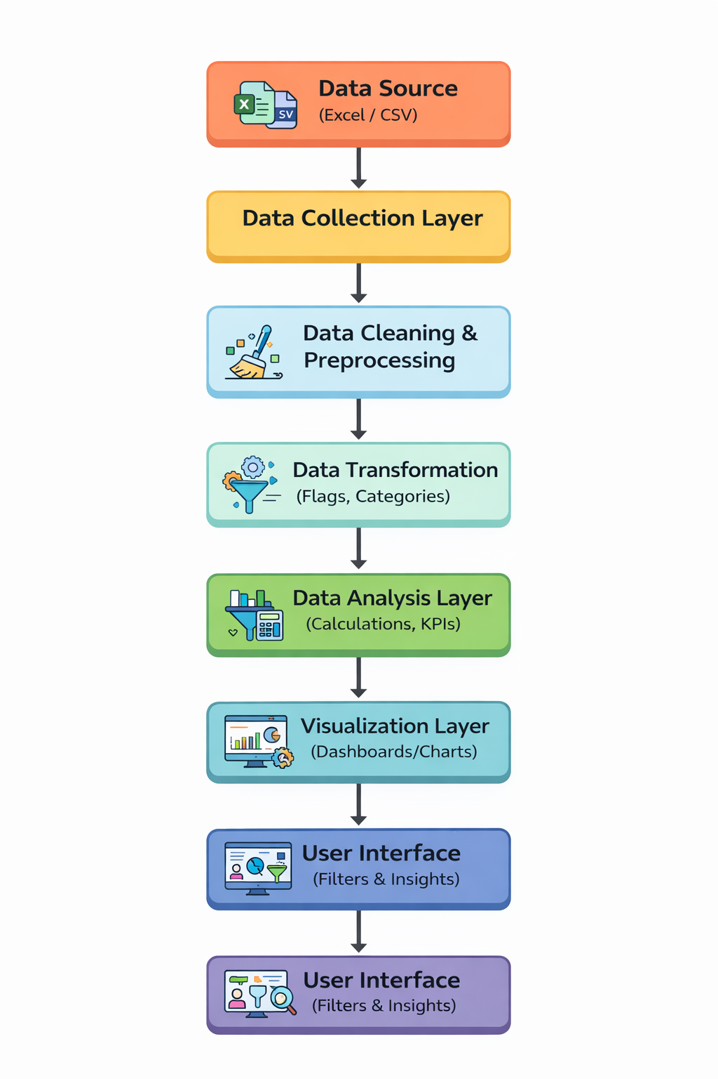
Explanation of Each Component
1. Data Source
This is the starting point of the system. The data is stored in files such as Excel or CSV. It contains all transaction details like item purchased, category, amount, location, size, discount usage, promo code usage, and subscription status. This raw data is unprocessed and needs to be prepared before analysis.
2. Data Collection Layer
In this stage, the system loads the data from the source into the working environment. The data is read and prepared for further processing. This step ensures that all records are available for analysis.
3. Data Cleaning and Preprocessing
This component is responsible for improving data quality. It handles missing values, removes duplicates, and corrects inconsistencies. For example, values like Yes and No are standardized, and numerical fields are properly formatted. This step ensures that the data is accurate and ready for analysis.
4. Data Transformation
In this stage, new columns are created to enhance analysis. Logical operations are applied to generate fields such as:
- Discount flag (1 or 0)
- Promo flag (1 or 0)
- Subscription flag (1 or 0)
- Revenue category (High or Low)
These transformations make the data easier to analyze and help in identifying patterns.
5. Data Analysis Layer
This component performs calculations and aggregations. It computes key metrics such as:
- Total sales
- Average transaction value
- Number of transactions
- Category-wise performance
The system groups and summarizes data to identify trends and patterns.
6. Visualization Layer
The processed data is then converted into visual formats such as charts, graphs, and dashboards. This layer presents the data in an easy-to-understand way. Common visuals include bar charts, pie charts, and KPI cards.
7. User Interface
This is the final layer where users interact with the system. Users can apply filters, select categories, and explore different views of the data. The interface allows users to gain insights without modifying the data directly.
Data Flow Step-by-Step
- The process starts with raw data stored in Excel or CSV files.
- The system collects and loads this data into the processing environment.
- The data is cleaned to remove errors and ensure consistency.
- New fields are created using transformation logic to enhance analysis.
- The system performs calculations and summarizes the data to generate useful metrics.
- The analyzed data is passed to the visualization layer where dashboards are created.
- Finally, users interact with the dashboard to explore insights and understand trends.
Summary
The block diagram represents a clear flow from raw data to final insights. Each component plays a specific role in transforming unprocessed data into meaningful information. The step-by-step flow ensures that the system works in an organized and efficient manner, making it easier to analyze retail sales data and support decision-making.

9. DATA ANALYTICS SECTION
9.1 Overview
Data analytics is the process of collecting, organizing, processing, and analyzing data to extract meaningful information and support decision-making. In simple terms, it converts raw data into useful insights that help understand patterns, trends, and relationships within the data.
In this project, data analytics plays a central role in analyzing retail sales data. The dataset contains multiple attributes such as item purchased, category, amount, location, size, discount usage, promo code usage, and subscription status. By applying data analytics techniques, the system is able to identify how these factors influence sales performance and revenue generation. Instead of just storing data, the system uses analytics to interpret the data and provide clear insights.
The importance of data analytics in this project lies in its ability to simplify complex data and make it understandable. Retail data can be large and difficult to interpret manually. Data analytics helps in organizing this data, identifying key patterns, and presenting the results in a structured way. This supports better understanding of customer behavior, product demand, and the impact of promotional strategies.
Data analytics also improves decision-making by providing factual insights instead of assumptions. For example, it helps identify which product categories generate higher revenue, how discounts affect sales, and which locations contribute more to overall performance. These insights are useful for planning strategies and improving business operations.
There are different types of data analytics used in this project, each serving a specific purpose:
- Descriptive Analytics
This type of analytics focuses on understanding what has already happened in the data. It summarizes past data using measures such as total sales, average transaction value, and number of purchases. In this project, descriptive analytics is used to analyze overall sales performance and identify basic trends.
- Diagnostic Analytics
Diagnostic analytics helps in understanding why certain patterns or trends occur. It involves comparing different variables to identify relationships. For example, analyzing how discount usage affects purchase amount or how subscription status influences buying behavior. This helps in explaining the reasons behind observed patterns.
- Predictive Analytics
Predictive analytics uses historical data to estimate future outcomes. Although this project mainly focuses on current data analysis, the structured dataset and insights can be used as a base for predicting future sales trends, customer behavior, or demand patterns.
- Prescriptive Analytics
Prescriptive analytics suggests actions based on the insights obtained. It helps in decision-making by recommending strategies such as applying discounts, targeting specific locations, or focusing on high-performing products. While not fully implemented, this project supports prescriptive thinking by providing clear insights.
Overall, data analytics is the core component of this project. It transforms raw retail data into meaningful information, helps in understanding sales patterns, and supports better decision-making in real-world retail scenarios.

9.2 Data Description
The dataset used in this project represents retail sales transactions and contains structured information about different purchases. Each row in the dataset corresponds to a single transaction, while each column represents a specific attribute related to that transaction. The dataset is organized in a tabular format, making it suitable for analysis and visualization.
The data includes both categorical and numerical fields, along with some derived columns that help in simplifying analysis. These attributes together provide a complete view of customer purchases, product details, and revenue-related information.
Description of Columns
- item_purchased
This column contains the name of the product purchased, such as blouse, sweater, jeans, or shirt. It is a categorical variable and helps in identifying individual product performance.
- category
This column represents the type of product, such as clothing, outerwear, or accessories. It is also a categorical field and is useful for analyzing category-wise sales and comparing performance across product groups.
- amount
This is a numerical column that indicates the transaction value or purchase amount. It is one of the most important fields, as it directly contributes to revenue analysis.
- location
This column shows the geographical location where the purchase was made, such as different states. It is a categorical variable and is useful for location-based analysis and identifying regional sales trends.
- size
This column represents the size of the product purchased, such as small, medium, or large. It is a categorical field and helps in understanding customer preferences related to product sizing.
- discount_applied
This column indicates whether a discount was applied to the transaction. It contains values like Yes or No and is used to study the effect of discounts on purchasing behavior.
- promo_code_used
This column shows whether a promotional code was used during the purchase. It is a categorical field with values Yes or No and helps in analyzing the effectiveness of promotional campaigns.
- subscription_status
This column indicates whether the customer is subscribed or not. It is used to compare the behavior of subscribed and non-subscribed customers.
- discount_flag
This is a derived numerical column where Yes is converted to 1 and No to 0. It simplifies analysis by allowing numerical calculations related to discount usage.
- promo_flag
This is another derived column representing promo code usage in numeric form, where Yes is 1 and No is 0. It is useful for aggregation and comparison.
- subscription_flag
This column converts subscription status into numeric form (1 or 0). It helps in analyzing customer segments more easily.
- revenue_category
This column categorizes transactions into groups such as High or Low based on the purchase amount. It is useful for identifying high-value transactions and understanding revenue distribution.
Types of Data
The dataset contains a mix of different data types:
- Categorical Data
Columns like item_purchased, category, location, size, discount_applied, promo_code_used, subscription_status, and revenue_category fall under this type. These are used for grouping and comparison.
- Numerical Data
Columns such as amount, discount_flag, promo_flag, and subscription_flag are numerical. These are used for calculations, aggregations, and statistical analysis.
Relevance of the Dataset
This dataset is highly relevant for retail sales analysis because it captures multiple factors that influence purchasing decisions and revenue. It allows the study of relationships between variables such as discounts and sales, promo codes and customer behavior, and product categories and revenue contribution.
By combining product details, customer-related information, and transaction values, the dataset provides a complete view of retail operations. This makes it suitable for identifying trends, comparing performance, and generating insights that support business decisions.
Overall, the dataset serves as the foundation for the entire analysis process, enabling the system to transform raw transaction data into meaningful insights about retail sales and product performance.

9.3 Data Preprocessing
Data preprocessing is an important step in this project, as it prepares the raw retail data for accurate analysis. The dataset initially may contain inconsistencies, missing values, or unstructured formats. Preprocessing ensures that the data is clean, consistent, and suitable for further analysis and visualization.
Data Cleaning
Data cleaning involves removing errors and inconsistencies from the dataset. In this project, the following steps are performed:
- Incorrect or inconsistent entries are identified and corrected. For example, values like Yes, yes, or YES are standardized into a single format.
- Duplicate records are checked and removed if present to avoid repeated analysis of the same transaction.
- Unnecessary spaces or formatting issues in text fields are cleaned to maintain consistency.
- Data types are verified to ensure numerical columns contain only numbers and categorical columns contain valid labels.
This step improves the quality of the dataset and ensures reliable analysis.
Handling Missing Values
Missing values can affect analysis results if not handled properly. In this dataset, missing data is managed using simple and effective methods:
- If missing values are minimal, the corresponding rows may be removed to maintain data integrity.
- For categorical columns, missing values can be replaced with a common value such as No or Unknown based on context.
- For numerical columns like amount, missing values can be filled using average or median values if required.
Handling missing values ensures that the dataset remains complete and usable for analysis.
Data Formatting
Formatting ensures that all data is in a consistent and usable structure. The following formatting steps are applied:
- Categorical values are standardized (for example, Yes or No instead of mixed formats).
- Numerical fields such as amount are converted into proper numeric data types.
- Column names are cleaned and formatted to maintain uniform naming conventions.
- Date or location formats, if present, are standardized for consistency.
Proper formatting allows smooth processing and avoids errors during analysis.
Feature Engineering
Feature engineering involves creating new columns from existing data to improve analysis. In this project, several derived features are created:
- Discount Flag
Converts discount_applied values into numeric form (Yes = 1, No = 0) for easier calculation.
- Promo Flag
Converts promo_code_used into numeric form (1 or 0) to analyze promotional impact.
- Subscription Flag
Converts subscription_status into numeric format to compare customer segments.
- Revenue Category
Classifies transactions into categories such as High or Low based on the amount. This helps in identifying high-value transactions.
These new features simplify analysis and allow better comparison and aggregation of data.
Summary
Data preprocessing transforms raw data into a clean and structured format. By performing cleaning, handling missing values, formatting, and feature engineering, the dataset becomes ready for accurate and efficient analysis. This step ensures that the insights generated in later stages are meaningful and reliable.

9.4 Exploratory Data Analysis (EDA)
Exploratory Data Analysis is performed to understand the underlying patterns, trends, and distributions present in the retail dataset. It helps in summarizing the data and identifying relationships between different variables before building further analysis or visualization. In this project, EDA focuses on understanding how different factors such as product category, amount, location, discounts, and subscription status influence retail sales.
Overall Sales Distribution
The analysis of the amount column shows how transaction values are distributed across the dataset. The data typically contains a mix of low and high-value transactions, indicating variation in customer spending behavior. Most transactions tend to fall within a moderate range, while a smaller number of transactions contribute to higher revenue. This distribution helps in identifying the presence of both regular purchases and high-value purchases.
The classification into revenue categories such as High and Low further simplifies this understanding. A noticeable portion of transactions falls into the high revenue category, indicating that certain products or conditions lead to increased spending.
Category-wise Analysis
When analyzing sales based on product categories, it becomes clear that some categories contribute more to revenue than others. For example, categories like clothing often have a higher number of transactions due to frequent purchases, while categories like outerwear may have fewer but higher-value transactions.
This indicates that different categories have different purchasing patterns. Some categories drive volume, while others contribute more to revenue per transaction. Understanding this distinction helps in identifying which categories are key contributors to overall sales.
Item-level Patterns
At the individual product level, certain items appear more frequently in transactions. This suggests higher demand for those items. At the same time, some items are associated with higher transaction amounts, indicating premium or higher-priced products.
This analysis helps in distinguishing between popular products and high-value products. Both types are important, as one drives sales frequency while the other drives revenue.
Location-based Trends
Geographical analysis shows that sales vary across different locations. Some locations have a higher number of transactions, while others may show higher average transaction values. This variation can be due to differences in customer preferences, economic conditions, or regional demand.
Identifying such trends helps in understanding which regions contribute more to sales and where there is potential for growth.
Impact of Discounts
The dataset shows that a large number of transactions involve discounts. This indicates that discounts play a significant role in influencing customer purchases. In many cases, transactions with discounts are associated with increased purchase frequency.
However, when comparing transaction amounts, it can be observed that discounts do not always lead to higher revenue per transaction. Instead, they often encourage more purchases, which contributes to overall sales volume.
Promo Code Usage Patterns
Promo code usage follows a pattern similar to discounts. Many transactions involve promo codes, suggesting that promotional strategies are actively influencing customer behavior. Customers who use promo codes are often more engaged and responsive to offers.
The comparison between transactions with and without promo codes helps in understanding how promotions affect both sales volume and revenue.
Subscription-based Behavior
Customers with subscription status show different purchasing behavior compared to non-subscribers. Subscription users tend to have more consistent purchasing patterns and may be more likely to use discounts or promo codes.
This indicates that subscription models can influence customer loyalty and engagement, leading to repeated purchases and stable revenue.
Size Preferences
The analysis of product size reveals that certain sizes are more frequently purchased than others. This indicates customer preference patterns and can help in understanding demand distribution across sizes.
Such insights are useful for inventory planning and ensuring that frequently demanded sizes are adequately stocked.
Relationship Between Variables
EDA also helps in identifying relationships between multiple variables. For example:
- Discounts and promo codes are often used together in transactions
- Higher transaction amounts are sometimes associated with specific categories
- Subscription users may show higher engagement with promotional offers
These relationships help in understanding how different factors interact with each other to influence purchasing decisions.
Summary
Exploratory Data Analysis provides a clear understanding of the dataset by highlighting patterns, trends, and relationships. It shows how different variables such as category, amount, location, discounts, and subscription status affect retail sales. The insights obtained from EDA form the foundation for further analysis and help in making informed decisions based on data.

9.5 TOOLS USED
The following tools are used in this project to perform data processing, analysis, storage, and visualization. Each tool plays a specific role in the overall workflow.
1. Python
Python is the core programming tool used for implementing the entire data analysis process. It is used to write scripts for data cleaning, transformation, and analysis.

2. Jupyter Notebook
Jupyter Notebook is used as the development tool where Python code is written and executed. It provides an interactive environment to run code step-by-step and view outputs instantly.

3. Pandas
Pandas is used for data manipulation and handling structured data. It helps in reading datasets, filtering data, grouping values, and creating new columns required for analysis.

4. NumPy
NumPy is used for numerical computations. It supports mathematical operations and helps in handling arrays and performing calculations efficiently.

5. Matplotlib
Matplotlib is used for creating visualizations such as bar charts and histograms. It helps in understanding patterns and trends in the dataset during analysis.

6. MySQL
MySQL is used as the database tool for storing and managing the dataset. It allows execution of SQL queries to retrieve and analyze data efficiently.

7. Microsoft Power BI
Power BI is used as the visualization and reporting tool. It is used to create interactive dashboards, charts, and KPI indicators for better understanding of insights.

Summary
These tools work together to form a complete data analytics pipeline. Python and its libraries handle data processing, MySQL manages data storage, and Power BI provides visualization, making the system efficient and easy to use.

10. SOFTWARE REQUIREMENTS
Software requirements refer to the platforms and environments needed to develop, run, and execute the project. These provide the base setup where all tools and libraries function.
1. Operating System
The project can run on operating systems such as Windows, macOS, or Linux. In this project, a Windows environment is typically used, which supports Python, Jupyter Notebook, and other required tools. The operating system manages file handling, software installation, and execution of programs.

2. Python Environment
Python is required as the core programming language. A proper Python environment must be installed to execute scripts and run data analysis.
In this project:
- Python is used to write all preprocessing and analysis logic
- It acts as the base for libraries like pandas, NumPy, and matplotlib
- Version compatibility is important to ensure smooth execution

3. Jupyter Notebook Environment
Jupyter Notebook is required as the development platform for writing and running code interactively.
In this project:
- It provides an interface to execute Python code step-by-step
- It allows combining code, outputs, and explanations in one place
- It helps in testing and debugging during development

4. Library Support (Python Packages)
The system requires installation of essential Python libraries. These are not standalone software but part of the Python environment.
Required libraries include:
- pandas for data handling
- NumPy for numerical operations
- matplotlib for visualization
These libraries must be installed using package managers such as pip before running the project.

5. Database Software (MySQL)
MySQL is used as the database system for storing and querying structured data.
In this project:
- It stores insurance dataset in table format
- SQL queries are executed to filter and analyze data
- It supports structured data management and retrieval

6. Data Visualization Software (Microsoft Power BI)
Power BI is required for creating dashboards and visual reports.
In this project:
- It connects to processed data
- It is used to build interactive dashboards
- It helps in visualizing insights using charts and KPI cards

7. Web Browser
A web browser such as Chrome or Edge is required to access Jupyter Notebook and Power BI interfaces. It provides the interface for interacting with dashboards and notebooks.

Summary
The software requirements define the environment needed to run the project successfully. Python and Jupyter Notebook provide the development platform, MySQL manages data storage, and Power BI handles visualization. Together, these components create a complete system setup for executing the insurance data analytics project.
11. HARDWARE REQUIREMENTS
1. Processor
- Minimum Intel Core i3 or equivalent
- Recommended Intel Core i5 or higher
The processor is responsible for executing all operations in the system. A basic processor like i3 can handle small datasets and simple analysis. However, for better performance, especially when running multiple tools such as Jupyter Notebook and Power BI together, a higher processor like i5 or above is preferred. A faster processor reduces computation time and improves overall system responsiveness.
2. RAM
- Minimum 4 GB RAM
- Recommended 8 GB or more
RAM is used to temporarily store data during execution. A minimum of 4 GB is sufficient for basic tasks, but it may cause slow performance when handling larger datasets. Using 8 GB or more allows smoother multitasking and faster data processing. Higher RAM ensures that the system does not lag when multiple applications are running.
3. Storage
- Minimum 256 GB storage
- Recommended SSD storage
Storage is required to install software and store datasets and project files. A minimum of 256 GB is needed for proper functioning. Solid State Drives are recommended over traditional hard drives because they provide faster data access and improve system speed. Faster storage reduces loading time and enhances performance.
4. Operating System
- Windows, macOS, or Linux supported
- Recommended 64-bit Windows 10 or above
The operating system acts as the base platform for running all tools and applications. A 64-bit system is recommended for better compatibility and performance. Windows 10 or higher is commonly used as it supports all required software such as Python, MySQL, and Power BI efficiently.
Summary
The hardware components play an important role in ensuring smooth execution of the project. A good processor, sufficient RAM, fast storage, and a compatible operating system together provide a stable and efficient working environment.

Why These Hardware Requirements Are Sufficient for the Project
The specified hardware configuration is sufficient for this project because the nature of the work involves moderate data processing, analysis, and visualization, rather than extremely heavy computations or large-scale distributed systems. Each component supports the project requirements effectively.
Processor Sufficiency
The project mainly uses Python, Jupyter Notebook, SQL queries, and Power BI dashboards. These tasks involve data manipulation, filtering, grouping, and visualization, which do not require very high-end processing power. A processor like Intel Core i3 can handle these operations without major issues. However, using an i5 or higher ensures faster execution when performing multiple operations or running several tools at the same time. Since the dataset is of manageable size and not extremely large, this level of processing power is sufficient.
RAM Sufficiency
The dataset used in this project is structured and moderate in size, meaning it can easily fit into memory. A minimum of 4 GB RAM is enough to load and process such data in pandas and NumPy. However, when using tools like Power BI along with Jupyter Notebook, additional memory is beneficial. With 8 GB RAM, the system can handle multitasking smoothly, ensuring that data analysis, visualization, and querying operations run without lag. Therefore, this RAM range is adequate for efficient performance.
Storage Sufficiency
The project requires storage for datasets, software installations, and output files such as reports and dashboards. The data size is not extremely large, so 256 GB storage is more than enough to accommodate all files. Using SSD storage further improves performance by reducing loading times and speeding up file access. This ensures quick opening of datasets, faster execution of notebooks, and smooth operation of Power BI dashboards.
Operating System Sufficiency
The project tools such as Python, Jupyter Notebook, MySQL, and Power BI are fully compatible with modern operating systems like Windows, macOS, and Linux. A 64-bit operating system ensures better memory utilization and supports all required software efficiently. Windows 10 or above is commonly used and provides a stable environment for running all components without compatibility issues. Therefore, the operating system requirement is sufficient for seamless execution.
Overall Justification
The project does not involve heavy machine learning models, real-time big data processing, or high-performance computing tasks. Instead, it focuses on structured data analysis, visualization, and dashboard creation. The specified hardware is capable of handling these operations efficiently without unnecessary resource usage. It provides a balanced configuration that ensures smooth performance, cost-effectiveness, and practical usability for real-world implementation.

12. METHODOLOGY
The methodology of this project follows a structured step-by-step process to transform raw retail data into meaningful insights. Each stage plays an important role in ensuring that the final analysis is accurate, clear, and useful for decision-making.
1. Data Collection
The first step in the project is data collection. The dataset is gathered from sources such as Excel files or structured datasets containing retail transaction details. Each record includes information like item purchased, category, amount, location, size, discount usage, promo code usage, and subscription status.
The collected data serves as the foundation for the entire project. It is important that the data is complete and contains all relevant attributes required for analysis.
2. Data Preprocessing
After collecting the data, preprocessing is performed to prepare it for analysis. This step ensures that the data is clean, consistent, and structured.
- Errors and inconsistencies are corrected
- Missing values are handled appropriately
- Data formats are standardized
- New features such as discount flag, promo flag, subscription flag, and revenue category are created
This step improves data quality and makes it suitable for further processing.
3. Data Analysis
Once the data is prepared, analysis is performed to identify patterns and trends. Various calculations and aggregations are applied to the dataset.
- Total and average sales are calculated
- Category-wise and location-wise performance is analyzed
- Impact of discounts and promo codes is studied
- Customer behavior based on subscription status is examined
This step helps in understanding how different factors influence retail sales and revenue.
4. Data Visualization
After analysis, the results are presented using visual elements such as charts, graphs, and dashboards. Visualization makes it easier to understand complex data and identify trends quickly.
- Bar charts are used for category comparisons
- Pie charts show distribution of data
- KPI cards display key metrics like total sales and transaction count
- Filters allow users to explore data dynamically
Visualization improves clarity and helps users interpret the results effectively.
5. Insights Generation
The final step is generating insights from the analysis and visualizations. The patterns observed in the data are converted into meaningful conclusions.
- High-performing categories and products are identified
- The effect of discounts and promotions is understood
- Customer behavior patterns are recognized
- Regional sales trends are analyzed
These insights help in making informed decisions and improving retail strategies.
Summary
The methodology follows a logical flow from data collection to insight generation. Each step builds on the previous one, ensuring that raw data is transformed into valuable information in a systematic and efficient manner.

13. UML DIAGRAMS
Use Case Diagram
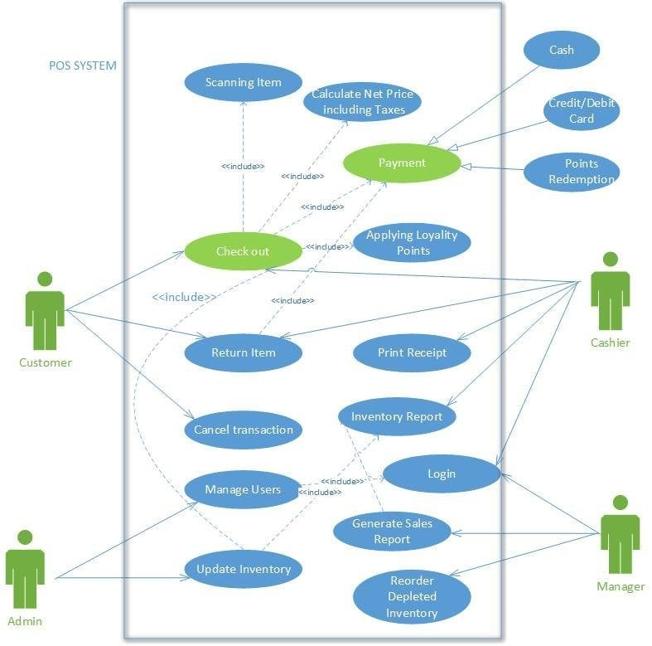
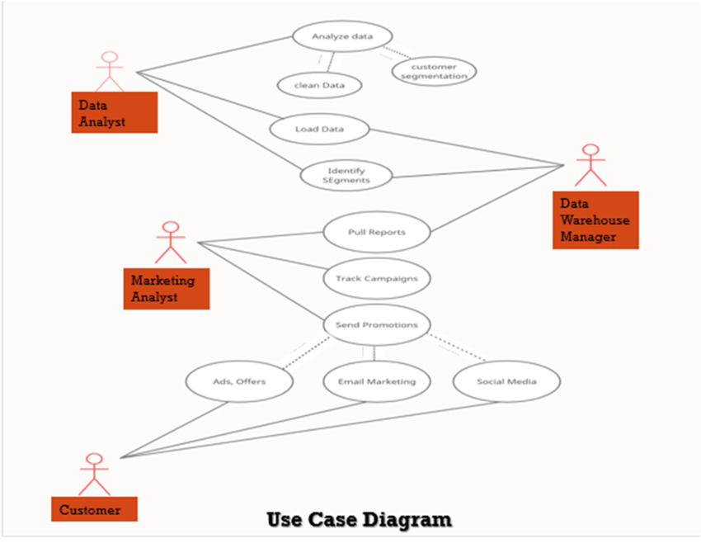

4
The Use Case Diagram represents how users interact with the system and what actions they can perform.
Actors:
- User (Analyst / Manager)
Main Actions:
- Upload Data
- Clean and Process Data
- Analyze Sales Data
- View Dashboard
- Apply Filters
- Generate Insights
Explanation:
The user is the primary actor who interacts with the system. The process starts with uploading the dataset. The system then processes the data, after which the user can analyze it through dashboards. The user can apply filters such as category, location, or discount usage to explore specific insights. This diagram shows how the system supports user-driven analysis.

Class Diagram
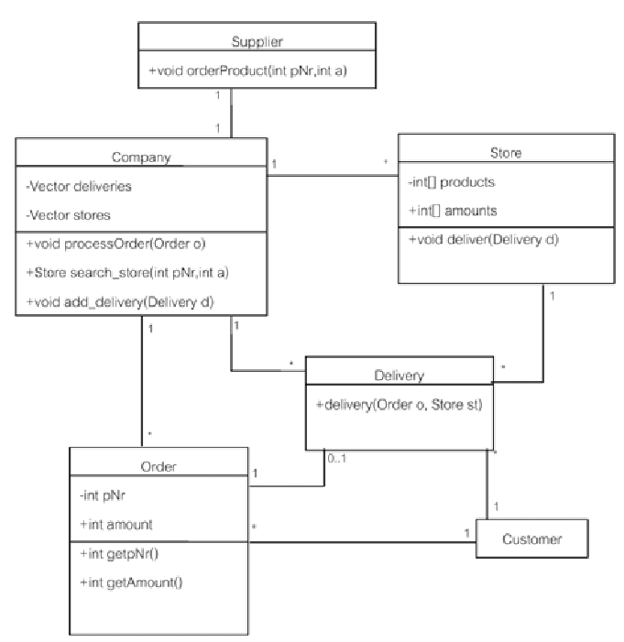
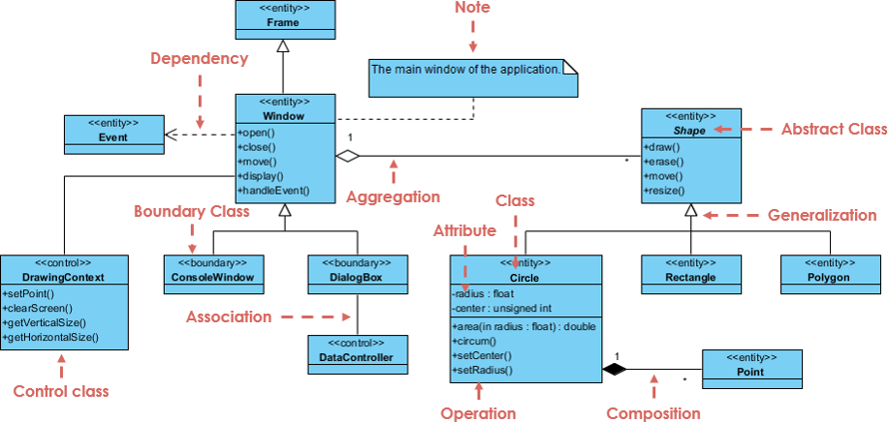
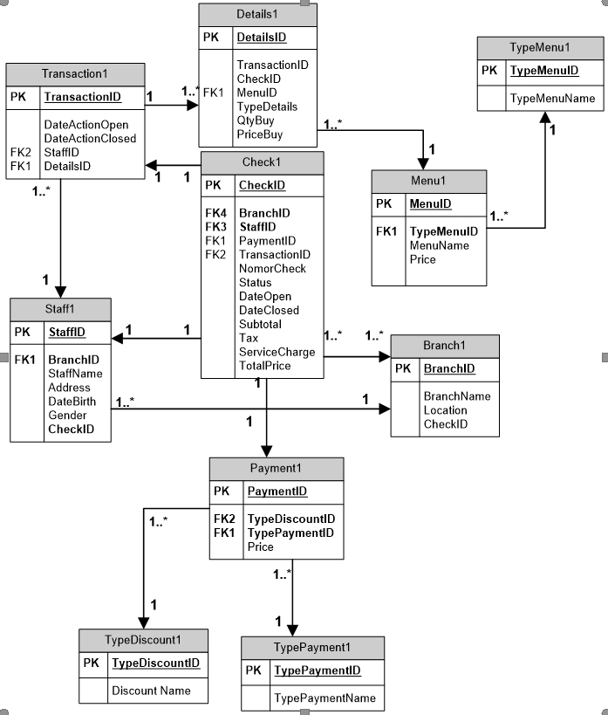
4
The Class Diagram represents the structure of the system by showing different classes, their attributes, and relationships.
Main Classes:
- Transaction
  - item_purchased
  - category
  - amount
  - location
  - size
- Customer
  - subscription_status
  - subscription_flag
- Promotion
  - discount_applied
  - promo_code_used
  - discount_flag
  - promo_flag
- Revenue
  - amount
  - revenue_category
Relationships:
- A Transaction is linked with Customer and Promotion
- Revenue is derived from Transaction
- Promotion influences Transaction value
Explanation:
This diagram shows how data is organized into logical components. Each class represents a part of the dataset. The relationships explain how different data elements are connected, helping in structured analysis.

Sequence Diagram
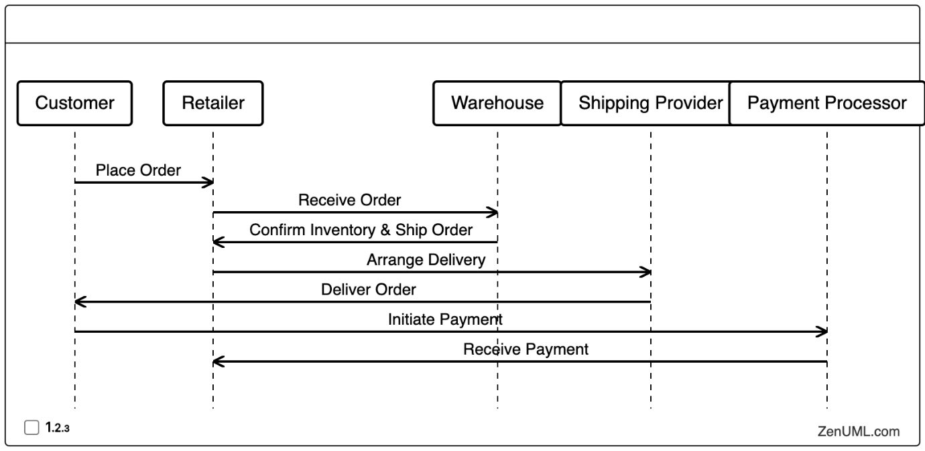
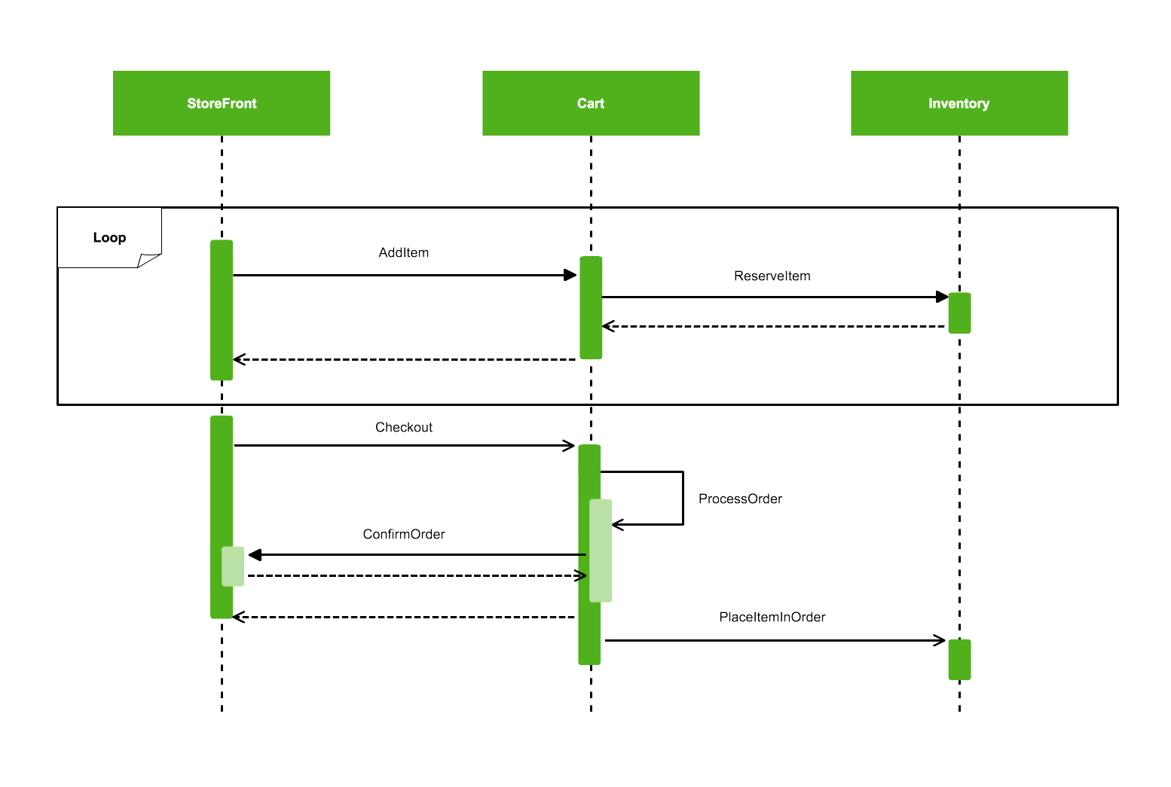
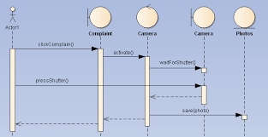
4
The Sequence Diagram shows the step-by-step interaction between different components of the system over time.
Flow of Interaction:
- User uploads dataset
- System reads and loads data
- Data preprocessing is performed (cleaning and formatting)
- Feature engineering is applied (flags and categories created)
- Data analysis is executed (calculations and aggregations)
- Results are sent to visualization layer
- Dashboard is displayed to user
- User interacts using filters and views insights
Explanation:
This diagram explains how data flows through the system step by step. It shows the order in which operations occur and how the user interacts with the system. It highlights the complete lifecycle from raw data input to final insight generation.

Summary
The UML diagrams together provide a complete understanding of the system:
- Use Case Diagram explains user interaction
- Class Diagram explains system structure
- Sequence Diagram explains workflow
These diagrams help in visualizing how the system operates, how data is structured, and how different components interact with each other.
Outputs:
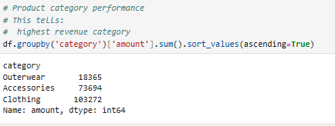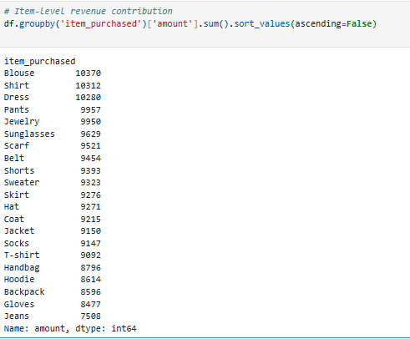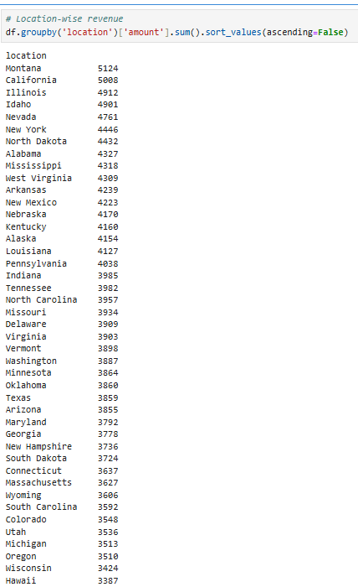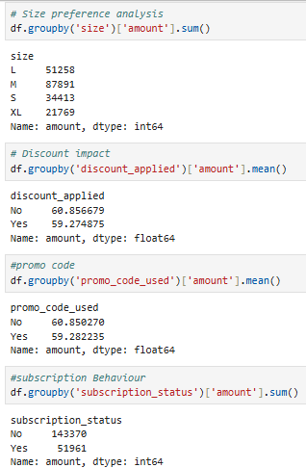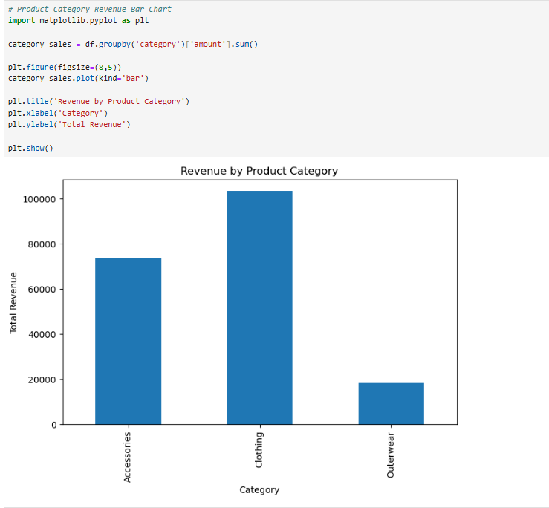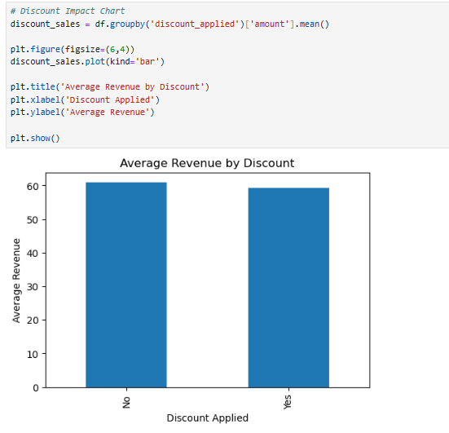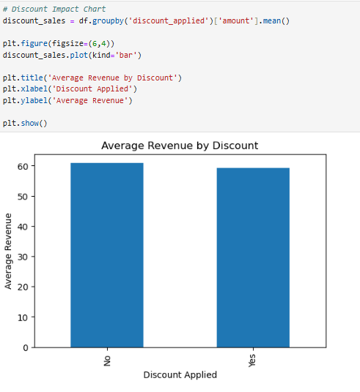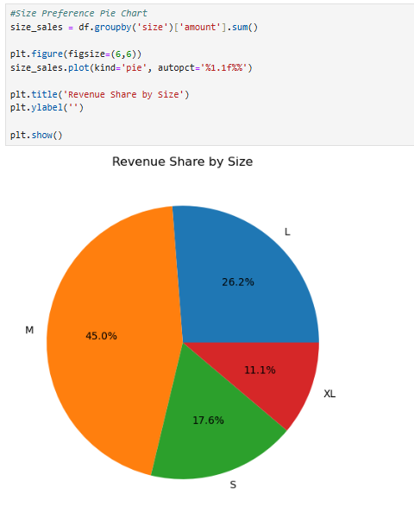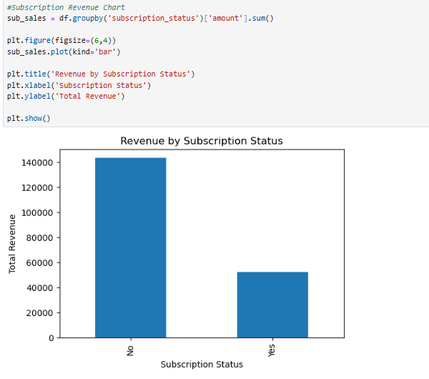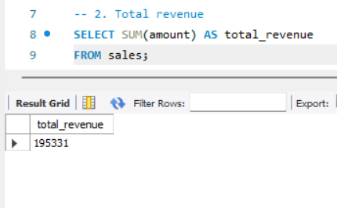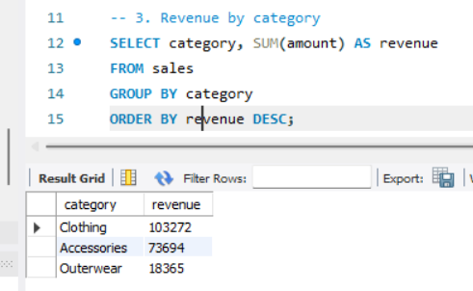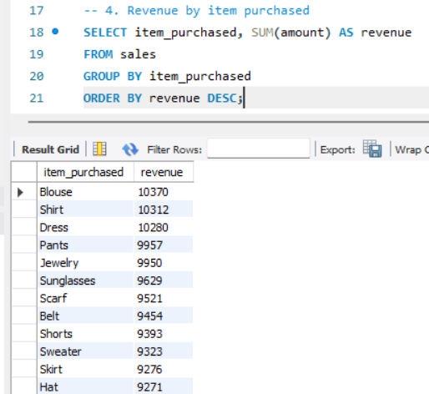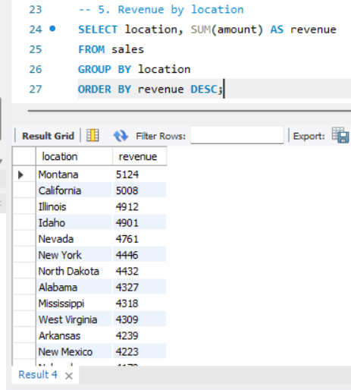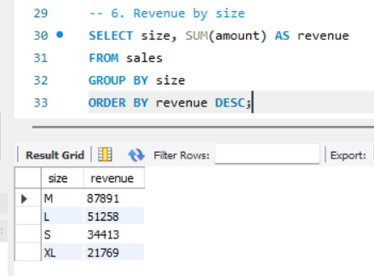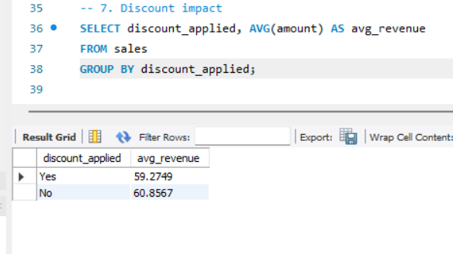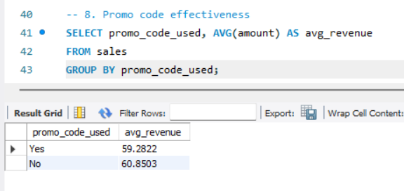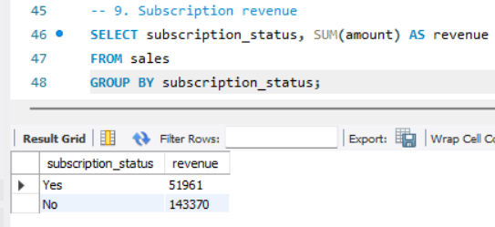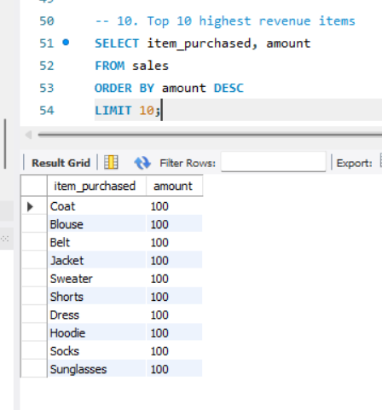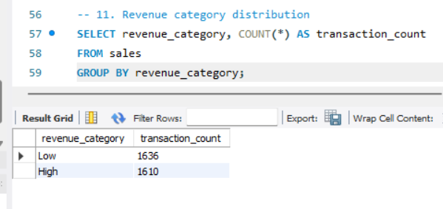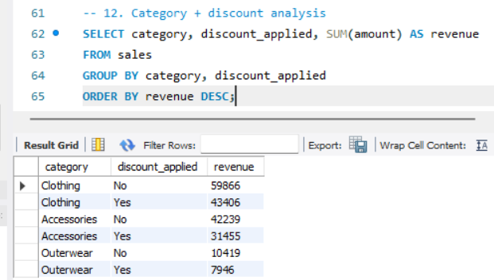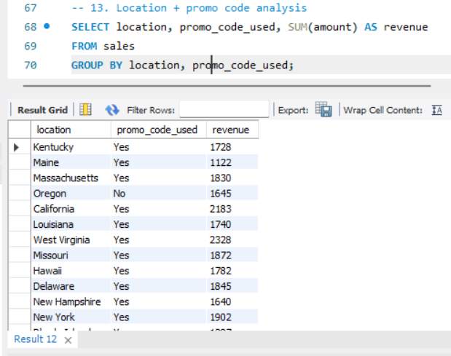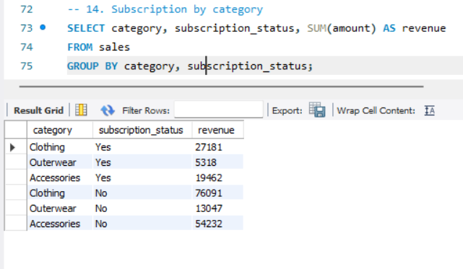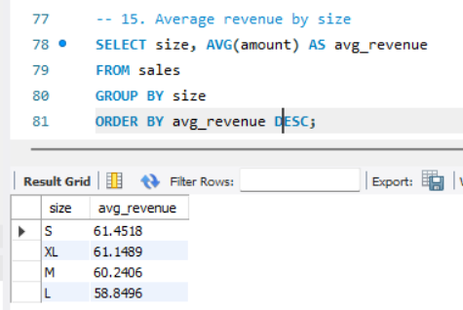

14. OUTPUS ANALYSIS
Output 1: Overall Sales Summary (KPI Cards)
The first output presents key performance indicators such as total sales, total transactions, average transaction value, high-value transactions, and weekend transactions. This section gives a quick overview of the entire dataset. The total sales value reflects the overall revenue generated, while the total number of transactions indicates customer activity. The average transaction value shows how much a customer spends per purchase on average.
From this output, it is observed that while the number of transactions is high, only a portion of them contribute to high-value sales. This indicates a mix of regular and premium purchases. The presence of weekend transactions suggests that customer activity may increase during specific periods. Overall, this output highlights the general performance of the retail system and sets the base for deeper analysis.

Output 2: Category-wise Sales Analysis
This visualization shows how different product categories contribute to total sales. Categories such as clothing, outerwear, and accessories are compared based on revenue or transaction count.
The pattern indicates that some categories generate more frequent purchases, while others contribute higher revenue per transaction. For example, clothing may show a higher number of transactions, indicating regular demand, whereas outerwear might show fewer but higher-value purchases. This suggests that different product categories play different roles in the business, with some driving volume and others driving revenue.
The insight from this output is that businesses should balance both high-demand and high-value categories to maximize overall performance.

Output 3: Location-wise Sales Distribution
This output displays how sales are distributed across different locations. Each location contributes differently to total revenue and transaction count.
The trend shows that certain locations generate higher sales compared to others. This variation indicates that customer behavior and demand differ by region. Some areas may have more frequent purchases, while others may have higher spending per transaction.
The insight here is that location plays an important role in retail performance. Businesses can use this information to focus on high-performing regions and improve strategies in lower-performing areas.

Output 4: Discount Impact Analysis
This visualization compares transactions with and without discounts. It shows how discounts influence sales volume and revenue.
The pattern suggests that a large number of transactions involve discounts, indicating that customers are responsive to offers. However, the average transaction value may not always be significantly higher with discounts. Instead, discounts tend to increase the number of purchases rather than the value of each purchase.
The key insight is that discounts are effective in driving sales volume, but they need to be managed carefully to maintain profitability.

Output 5: Promo Code Usage Analysis
This output highlights how promo codes are used in transactions and their impact on sales.
The trend shows that a significant portion of customers use promo codes, indicating strong engagement with promotional campaigns. Customers using promo codes may show higher purchasing activity.
The insight is that promo codes are an effective marketing tool. They help in attracting customers and encouraging purchases, especially when combined with discounts.

Output 6: Subscription-based Customer Analysis
This visualization compares the behavior of subscribed and non-subscribed customers.
The pattern indicates that subscribed customers tend to have more consistent purchasing behavior. They may also show higher engagement with discounts and promotions.
The insight is that subscription models help in building customer loyalty and ensuring repeat purchases. This contributes to stable and predictable revenue.

Output 7: Revenue Category Distribution
This output divides transactions into high and low revenue categories.
The distribution shows that while most transactions fall into the lower revenue category, a smaller portion contributes significantly higher revenue. These high-value transactions play an important role in overall sales.
The insight is that both low-value frequent purchases and high-value transactions are important. Businesses should focus on increasing the number of high-value transactions while maintaining regular sales.

Output 8: Product Size Analysis
This visualization shows the distribution of purchases across different product sizes.
The pattern indicates that certain sizes are more frequently purchased, reflecting customer preferences. Some sizes dominate the sales, while others have lower demand.
The insight is that understanding size preferences helps in better inventory management. Businesses can ensure that high-demand sizes are always available.

Overall Analysis
Across all outputs, a clear pattern emerges that retail sales are influenced by multiple factors such as category, location, discounts, promotions, and customer type. The data shows that customer behavior is not uniform and varies based on these factors.
The combination of high transaction volume, promotional strategies, and customer segmentation plays a key role in revenue generation. Discounts and promo codes increase engagement, while subscription models improve consistency in purchases. Category and location analysis help in identifying strong and weak areas of performance.
Overall, the outputs together provide a complete picture of retail sales trends and product performance, enabling better understanding and decision-making.

15. OVERALL CONCLUSION
The retail sales analysis project provides a comprehensive understanding of how different factors influence product performance and revenue generation in an online retail environment. By analyzing the dataset through multiple stages such as preprocessing, exploratory analysis, visualization, and interpretation, the project successfully transforms raw transactional data into meaningful insights.
From the analysis, it is evident that retail sales are influenced by a combination of product characteristics, customer behavior, and promotional strategies. Product categories play a significant role, where some categories contribute through higher sales volume while others contribute through higher transaction value. This highlights the importance of maintaining a balanced product portfolio to ensure both consistent sales and strong revenue generation.
The study also shows that customer purchasing behavior varies based on several factors such as location, subscription status, and promotional engagement. Certain locations demonstrate higher sales performance, indicating regional differences in demand and customer preferences. Subscription-based customers tend to exhibit more consistent purchasing patterns, suggesting that loyalty programs can help in maintaining steady revenue.
Promotional strategies such as discounts and promo codes have a noticeable impact on customer behavior. The analysis indicates that these strategies are effective in increasing transaction frequency and customer engagement. However, they mainly influence the volume of purchases rather than significantly increasing the value of each transaction. This emphasizes the need for a balanced approach in using promotions to ensure profitability.
The classification of transactions into high and low revenue categories provides further insight into spending behavior. While most transactions fall into the lower range, a smaller number of high-value transactions contribute significantly to overall revenue. This indicates the importance of identifying and encouraging high-value purchases alongside maintaining regular sales activity.
The use of data analytics tools and visualization techniques in this project improves the overall efficiency and clarity of analysis. Interactive dashboards and structured workflows make it easier to explore data, identify trends, and generate insights. Compared to traditional methods, this approach reduces manual effort, minimizes errors, and supports faster decision-making.
From a learning perspective, this project demonstrates the complete lifecycle of a data analytics solution. It covers data collection, preprocessing, analysis, visualization, and interpretation. It highlights the importance of data quality, structured workflows, and the use of analytical tools in deriving meaningful insights. It also provides practical experience in understanding real-world retail data and applying analytical techniques to solve business problems.
Overall, the project successfully achieves its objective of analyzing retail sales trends and product performance. It provides valuable insights into customer behavior, promotional impact, and revenue distribution. The findings can be used to improve business strategies, optimize product offerings, and enhance customer engagement. This makes the project both practically relevant and analytically significant in the context of retail data analysis.
16. FUTURE SCOPE
The current project provides a strong foundation for retail sales analysis, but there are several opportunities to enhance the system further by incorporating advanced technologies and improving overall capabilities. The following areas outline the future scope of the project.
Advanced Analytics
The system can be extended to include more advanced analytical techniques beyond basic descriptive analysis. Techniques such as trend analysis, cohort analysis, and customer segmentation can be applied to gain deeper insights into customer behavior. For example, analyzing seasonal trends can help in understanding how sales vary over time, while segmentation can group customers based on purchasing patterns. This will allow businesses to make more targeted and data-driven decisions.
Another improvement can be the inclusion of comparative analytics, where performance is compared across time periods, regions, or product categories. This helps in identifying growth patterns and performance gaps more effectively.
Machine Learning Integration
Machine learning can be introduced to make the system more intelligent and predictive. Models can be developed to forecast future sales based on historical data, helping businesses plan inventory and marketing strategies in advance.
Customer behavior prediction is another important application. Machine learning algorithms can identify patterns and predict which customers are likely to make purchases, respond to promotions, or become loyal customers. Recommendation systems can also be implemented to suggest products to users based on their past behavior, improving customer experience and increasing sales.
Fraud detection and anomaly detection models can also be added to identify unusual transactions or patterns, improving system reliability and security.
Automation Enhancements
Automation can be further improved by implementing automated data pipelines. Instead of manually updating data, the system can automatically collect, clean, and process data from different sources in real time or at regular intervals.
Automated report generation is another enhancement, where dashboards and reports are updated automatically without manual intervention. Alerts and notifications can also be added to inform users about important changes, such as sudden increases or decreases in sales.
These improvements will reduce manual effort, increase efficiency, and ensure that the system always provides up-to-date insights.
Scalability Improvements
As the volume of data grows, the system can be scaled using advanced technologies such as cloud computing and distributed data processing. Moving from local storage to cloud platforms will allow the system to handle large datasets more efficiently.
The use of databases instead of flat files can improve data management and retrieval speed. Technologies like data warehouses can be introduced to store and manage large-scale historical data.
Additionally, integrating the system with real-time data streaming tools can enable continuous data updates, making the system more responsive and suitable for large retail environments.
Overall Future Vision
The future scope of this project lies in transforming it from a descriptive analytics system into a fully intelligent and automated decision-support system. By incorporating advanced analytics, machine learning, automation, and scalable infrastructure, the system can provide deeper insights, faster processing, and better support for business strategies.
These improvements will make the system more efficient, adaptable, and capable of handling real-world retail challenges, ultimately enhancing its practical value and long-term usability.

